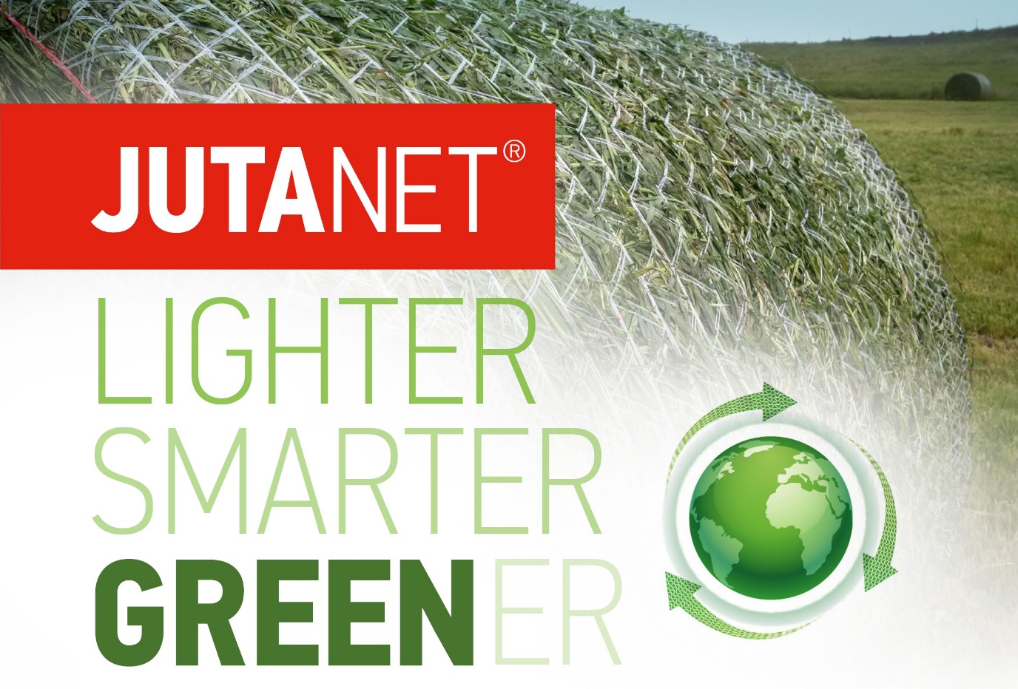
JUTANET GREEN WRAP represents a new level of round bale wrapping technology. Designed to meet the highest performance standards. Smarter net construction allows to reduce it´s density thus reducing plastic footprint.
The success of Jutanet Green Wrap is due to the weaving process, improved materials, and new net design. The result is net wrap that is lighter and stronger than standard net wraps available on the market today.
Along with its improved performance, Green Wrap has a smaller ecological footprint. Juta says it is very aware of the need to reduce the environmental impact of its production processes and the end use of its agricultural wrap, and Green Wrap does just this.
